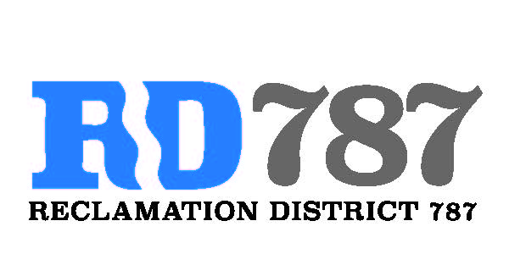

41758 County Road 112. Knights landing CA. 95645. Ph: 530 735-6274. Fax: 530 735-6734

**Minutes of the Special Board Meeting**

**March 3rd, 2020**

**9:00 am**

1. Call to Order – 9:00 am Chairman Roger Cornwell called the meeting to order

* Present were:

Board Members: Roger Cornwell, Joseph Hutchins

Attorney: None

Public: Dominic Bruno

1. Approval of Agenda for March 3rd, 2020
   * Additions to Agenda – no additions to the agenda

* Joseph Hutchins made a motion to approve, second Roger Cornwell– motion passed unanimously

1. Open Public Forum – Dominic Bruno did not present anything.
2. Approval of Resolution NO.20-01. Water Smart Grant proposal to meter the RD 787 discharge pumping stations and integrate with River Garden Farms SCADA system.
   * Joseph Hutchings made the motion to approve, second Roger Cornwell – motion passed unanimously.
3. Adjourn meeting was adjourned at 9:15 am