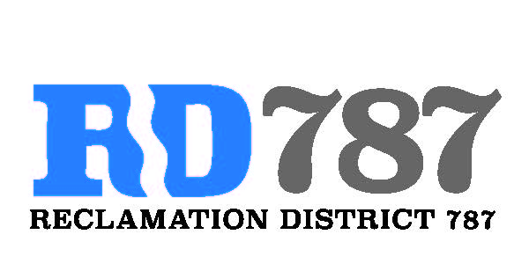

41758 County Road 112. Knights landing CA. 95645. Ph: 530 735-6274. Fax: 530 735-6734

**Minutes of the Board Meeting**

**February 5th, 2020**

**8:00 am**

1. Call to Order – 8:00 am Chairman Roger Cornwell called the meeting to order

* Present were:

Board Members: Roger Cornwell, Joseph Hutchins, Eric Faye

Attorney: None

Public: Dominic Bruno

1. Approval of Agenda for February 5th, 2020
   * Additions to Agenda – no additions to the agenda

* Joseph Hutchins made a motion to approve, second Eric Faye– motion passed unanimously

1. Open Public Forum – Dominic Bruno did not present anything.
2. Approval of Minutes from July 31st, 2019 meeting.

* Joey Hutchins made a motion to approve the minutes, second Eric Faye. Motion passed unanimously

1. Approval of 2018 Invoices to landowners:
   * Review of items and amounts
   * Eric Faye made a motion to approve the invoices, second Joey Hutchins. Motion passed unanimously
2. Approval of the 2019 Invoices to landowners
   * Review of items and amounts
   * New items offset by FMAP funding that is still outstanding
   * Discussion on amortizing the Can Pile pump repairs
   * Board moved to have Chairman Cornwell discuss with Faye Properties and bill accordingly.
   * Eric Faye made a motion to approve the invoices, second Joey Hutchins. Motion passed unanimously.
3. Approval of minimum RD 787 Charge to landowners.
   * Chairman Cornwell discussed increasing the minimum charge from $50 to $250 to keep up with increasing costs and improved facilities. He did note that it only affects Geer’s shop area.
   * Joseph Hutchins made the motion to approve, second Eric Faye. – Motion passed unanimously.
4. Chairman Cornwell gave an update on the SCADA funding the district has received to include the Faye Properties river diversion and new well. This funding will add meters and SCADA controls to the diversion and well. Now the district will know how much water is pumped into the district.
5. Chairman Cornwell gave an update on the district is going forward with pursuing a grant to add meters and SCADA to the drainage pumps. This would give the district good measurements on the amount of water used, and the amount of water pumped for winter drainage.
6. Chairman Cornwell gave an update on FMAP funding expenditures to the board. Increase in trash and debris pickup, increase amount of oat seeding in will done in November. Also burning and increase slope work has occurred over the last month.
7. Chairman Cornwell also informed the board that the fall inspections with DWR went well, the USACE also has performed another inspection of the district and we should have results in mid-2020.
8. Adjourn meeting was adjourned at 9:15 am