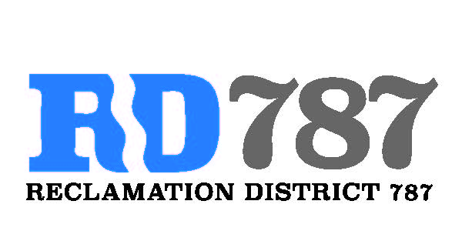

41758 County Road 112. Knights landing CA. 95645. Ph: 530 735-6274. Fax: 530 735-6734

**Board Meeting**

**April 9th, 2021**

**7:00 am**

**MODIFIED BROWN ACR PROCEDURES IN LIGHT OF COVID-19**

In compliance with CA Executive Orders N-25-20 and N-29-20, members of the Board of Directors and members of the public are suggested to participate in this meeting via teleconference/webinar. During this period of modified Brown Act Requirements, the District will use best efforts to swiftly resolve requests for reasonable modifications or accommodations with individuals with disabilities, consistent with the Americans with Disabilities Act, and resolving any doubt whatsoever in favor of accessibility.

1. Call to Order.
2. Approval of Agenda April 9th, 2021.
3. Open Public Forum.
4. Approval of Minutes from April 20th , 2020 Board Meeting..
5. Approve Resolution 21-01, Notice of Exemption for Maintenance.
6. Approve Resolution 21-02, FMAP funding proposal and designating the chairman to execute the agreement.
7. Hold public hear for River Garden Farms water transfer.
8. Adjourn.