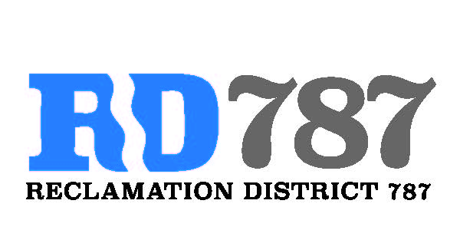

41758 County Road 112. Knights landing CA. 95645. Ph: 530 735-6274. Fax: 530 735-6734

**Board Meeting**

**February 5th, 2020**

**8:00 am**

1. Call to Order.
2. Approval of Agenda February 5th, 2020.
3. Open Public Forum.
4. Approval of Minutes from July 31st, 2019.
5. Approve 2018 invoices to landowners.
6. Approve 2019 invoices to landowners.
7. Approve Minimum RD 787 charge to landowners.
8. Update on SCADA system update Faye Properties.
9. Discuss SCADA system for all drainage pumps.
10. Update on FMAP program 2019, 2020.
11. General Update on RD 787
12. Adjourn