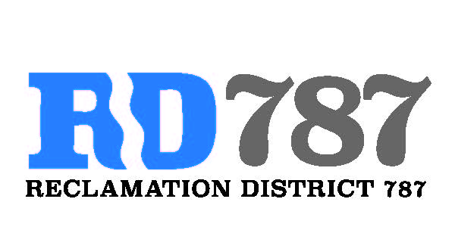

41758 County Road 112. Knights landing CA. 95645. Ph: 530 735-6274. Fax: 530 735-6734

**Board Meeting**

**July 31st, 2019**

**4:30 pm**

1. Call to Order.
2. Approval of Agenda for July 31st, 2019.
3. Open Public Forum.
4. Approval of Minutes from April 8th, 2019.
5. Approve Resolution NO. 19-10 Requesting FMAP funding for the Fiscal Year 2019-2020 and Authorizing the Chairman to execute FMAP Funding Agreement for the Fiscal Year 2019-2020.
6. Approve Resolution NO. 19-11 Accepting FMAO funds (Exhibit E of the attached Funding Agreement).
7. Update on Levee work
8. Approve Notice of Election and Nominating Petitions for the Office of Trustee, Reclamation District 787.
9. Approve Resolution NO. 19-12 Calling for an all mailed ballot Election.
10. Adjourn