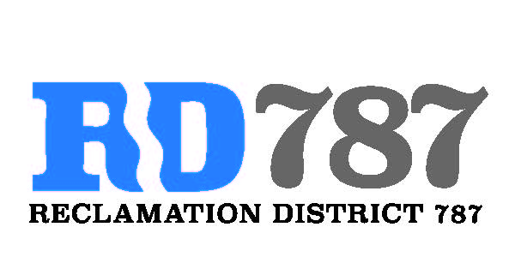

41758 County Road 112. Knights landing CA. 95645. Ph: 530 735-6274. Fax: 530 735-6734

**Minutes of the Board Meeting**

**February 6th, 2019**

**9:00 am**

1. Call to Order – 9:00 am President Roger Cornwell called the meeting to order

* Present were:

Board Members: Roger Cornwell, Joseph Hutchins, via telephone Eric Faye, Attorney: Rebecca Smith

Public: Alison Semichy (Faye Family), Dominic Bruno (River Garden Farms)

1. Approval of Agenda for February 6th, 2019
   1. Additions to Agenda – no additions to the agenda

* Joseph Hutchins made a motion to approve, second Eric Faye – motion passed unanimously

1. Open Public Forum
2. Approval of Minutes from September 28th, 2018 Special Meeting

* Eric Faye made a motion to approve the minutes, second Joseph Hutchins. Motion passed unanimously

1. Update on Board Election Process
   1. When to have elections
   2. How is up for re-election

* Ms. Smith assisted the board with a review and summary of the boards needs for terms and elections. Mr. Cornwell was advised on timing for elections, call for election in summer followed by election or appointment in the fall. 787 was advised to stagger the terms and elections so that not more than one board member election is occurring at a time

1. Officers Elections – The Board was asked is if there was any interest from other board members in assuming officer positions. Mr. Faye and Mr. Hutchins declined.
2. MOU: Memorandum of understanding between Reclamation District 787 and River Garden Farms for maintenance for Reclamation District 787 – Ms. Smith advised on and had drafted resolution 19-01, memorandum of understanding between RD787 and River Garden Farms to clearly layout respective rolls in the relationship and operation between the entities. Motion was passed by Joseph Hutchins, seconded by Eric Faye. The motion passed with 2 yes. Roger Cornwell abstained from the vote.
3. Flood Control
   1. Back Levee Repair

* Mr. Cornwell reported on the status of the repair with the Army Corps. After 3 meetings with the corps and consultation with KSN engineers the Corps is pushing for their original land side repair of the slip. Mr. Cornwell stated intent to involve Yolo County in the issue as there will be impacts to the county road from the proposed repair

1. Department of Water Resources Flood Maintenance Assistance Program
   1. Resolution 19-02: Authorizing a Proposal for funding from the Department of Water Resources and Designating a Representative to Execute the Agreement and any Amendments for the Flood Maintenance Assistance Program

* Resolution 19-02 will authorize Mr. Cornwell to act on behalf of RD 787 in pursuit of maintenance funding and reimbursement money from DWR
* Motion to pass resolution 19-02 by Eric Faye, second by Joseph Hutchins. Motion passed unanimously

1. Open Checking Account – River City Bank
   1. Resolution 19-03: Authorizing board chairman to open a checking account for Reclamation District 787

* Discussion in line with resolution 19-01. In order to better define the separation between RD 787 and River Garden Farms by opening an independent account. The account and distinct financials will help 787 in pusuit of funding and help with transparency. Document 19-03 prepared by Ms. Smith for the bank will authorize the opening of the account as well as document who has signature authority on account. Decision was made to authorize Ms. Smith / Downey Brand to apply on behalf of RD 787 for a federal tax ID
* Motion to approve the opening of a checking account at River City City Bank made by Eric Faye, second Joseph Hutchins. Motion passed unanimously

1. Yolo County LAFA rating-

* Review of the LAFA rating system and the RD 787 website
* Review by Ms. Smith regarding the legality of what is being requested by the County and what they information they are advising districts they represent to provide

1. Website Update

* Discussion of maybe contracting with someone to assist with website maintenance and updating

1. Adjourn meeting was adjourned at 9:25 am