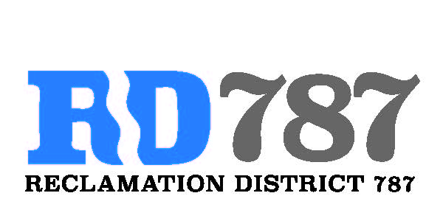

41758 County Road 112. Knights landing CA. 95645. Ph: 530 735-6274. Fax: 530 735-6734

**Board Meeting**

**April 20th, 2020**

**10:00 am**

1. Call to Order – 10:00 am Chairman Roger Cornwell called the meeting to order

* Present were: By conference call

Board Members: Roger Cornwell, Joseph Hutchins,

Attorney: None

Public: Dominic Bruno

1. Approval of Agenda for April 20th, 2020
   * Additions to Agenda – no additions to the agenda

* Eric Faye made a motion to approve, second Joseph Hutchins– motion passed unanimously

1. Open Public Forum – Dominic Bruno did not present anything.
2. Approval of the minutes from the February 5th, 2020 and March 3rd , 2020 special board meeting.
   * Joseph Hutchins made a motion to approve, second Eric Faye – motion passed unanimously
3. Approval of Resolution NO.20-02, Notice of exemption for Maintenance
   * Eric Faye made the motion to approve, second Joseph Hutchins – motion passed unanimously.
4. Approval of Resolution NO.20-03, Resolution Accepting FMAP 20201 Funding.
   * Joseph Hutchins made a motion to approve, second Eric Faye – motion passed unanimously
5. Adjourn meeting at 10:45 am.