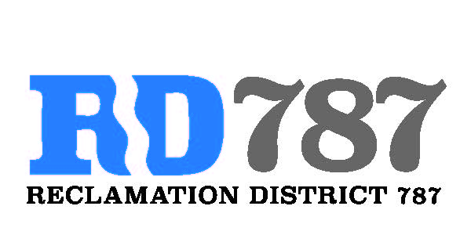

41758 County Road 112 . Knights landing CA . 95645 . Ph: 530 735-6274 . Fax: 530 735-6734

**Notice of Special Meeting Agenda Board of Directors Reclamation District 787**

**Wednesday, December 28.2022**

**10:00 Am**

1. **Call to Order**
   1. **Called to order 10:00**
2. **Public Comment** 
   1. **none**
3. **Inspections report – Dominic Reported 10:09**
   1. **Canpile pump repairs 2023 – advised that one pump is having issues and is bound up**
   2. **Canpile meter project completion – report on completion of watersmart 2020 grant work and now finalize project**
4. **Resolution 2022-2 – resolution to accept FMAP 2023 Maintenance Funding from DWR**

* **Eric made motion to accept – authorize Dominic to Sign**
* **Roger second**
* **Approval unanimous**

**No further discussion**

1. **Any Additional Business – none**
2. **Adjourn 10:11**